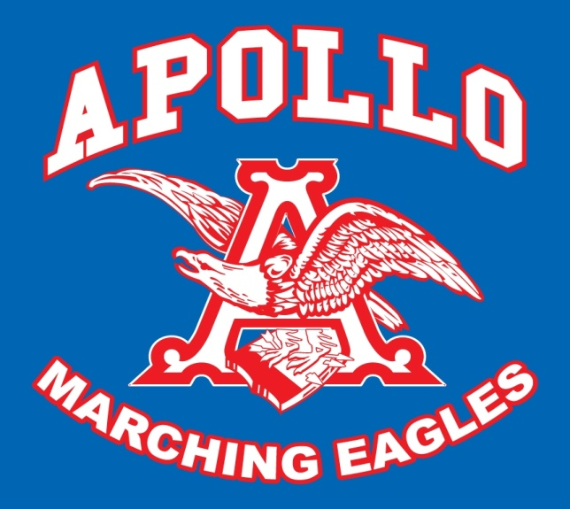

ORDER FORM
FOR TEES and HOODIES
All t-shirts are pre-shrunk cotton and royal blue
Short sleeve t-shirts in XS, S, M, L, XL & 2X sell for $12.00 each
Zippered Hoodies in XS, S, M, L, XL, and 2X are $30.00 each
Pullover Hoodies are $22.00 each

Order one for student, parents, brothers & sisters to show our band spirit!

Please indicate below number of each size ordered

Short-Sleeved T-shirts:
XS____S____M____L____XL____XXL____ Total @ 12.00 each_______

Zipper Hoodie
XS____S____M____L____XL____XXL____ Total @ 30.00 each_______

Pullover Hoodie
XS____S____M____L____XL____XXL____ Total @ 22.00 each_______

Total _______

CONTACT INFORMATION:
Student Name_______________________
Address____________________________
Parent Name________________________
Parent e-mail________________________
Parent home phone___________________
Parent cell phone_____________________

